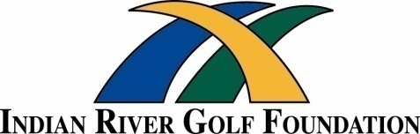
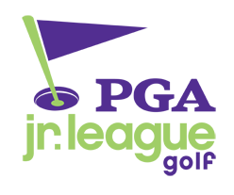
2 2021 Player's Club
PGA Junior League Golf - Indian River
June - July - August

The Indian River Golf Foundation is once again joining PGA Junior League Golf. PGA Junior League is a training, practice, and tournament summer program offered by the South Florida PGA at the local level and PGA of America at the regional and national level.

Program Features
1) Offered to all players ages 13 & under.
2) Four Teams of 12 players per team (boys & girls) will be determined with Parent Coaches assisting each team and will participate in June, July, and August
3) Four 2-person Scramble Teams play matches (MATCH PLAY format) vs. other teams in the league.
4) Entry deadline and fee: April 2021 on a first-come first-serve basis. Fee: $175 ($75 National + $100 Local)
Entry Fee Scholarships Available
5) Once all matches have been completed a League All-Star Team will be selected to advance to regional and national tournaments.

Program Benefits
As a member of the PGA Junior League Golf, players will receive the following benefits:
1) PGA Junior League Logo TEAM Shirt
2) PGA Junior League TEAM Bag Tag
3) IRGF Player's Club Membership Card

NEW IRGF Player's Club Membership Card benefits:
1) Golf Privileges at area public golf facilities for $1.00 per round
2) Range Balls at area public golf facilities for $1.00 per token.
3) "1031" Family Access Program $10 for playing adult with cart with up to 3 junior golfers at a rate of
$1 per junior at participating golf facilities.
4) Practice & Team Qualifying rounds at area public & private golf facilities.
5) 20% Discount at the IRGF Player's Club store.

For additional information on PGA Junior League Golf, contact:

Roger Van Dyke, Co-Captain rogervandykeirgf@gmail.com (772) 713-9593
Melanie Mark, Co-Captain melcmark@gmail.com (772) 913-1427

2021 PGA Junior League Golf Schedule
Training - Practice Sessions - Competitions
Note: Training/Practice Sessions scheduled during weekdays and Saturday afternoon sessions of the IRGF Player's Club
Team Practices:
June dates to be determined

Match Play Competitions - Regular Season (June - July)
June & July dates to be determined

All Star Team:
Following league competitions PGA Junior League All-Star Team selection process will begin based upon Skills Evaluation Index, individual competition experience, and other criteria.
All-Star Team will be represented by Co-Captains Roger Van Dyke & Melanie Mark

Match Play Competitions - Post Season (August - September) - To be determined
www.pgajrleaguegolf.com
www.irgf.org



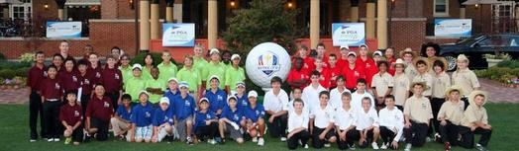
2014 PGA Junior League Golf National Championship Welcome Reception/Dinner - Medinah Country Club - Chicago, IL
Back Row: IRGF Players Sarah Noonan - Griffin Thompson - Corey Stepanek in Green Shirts

