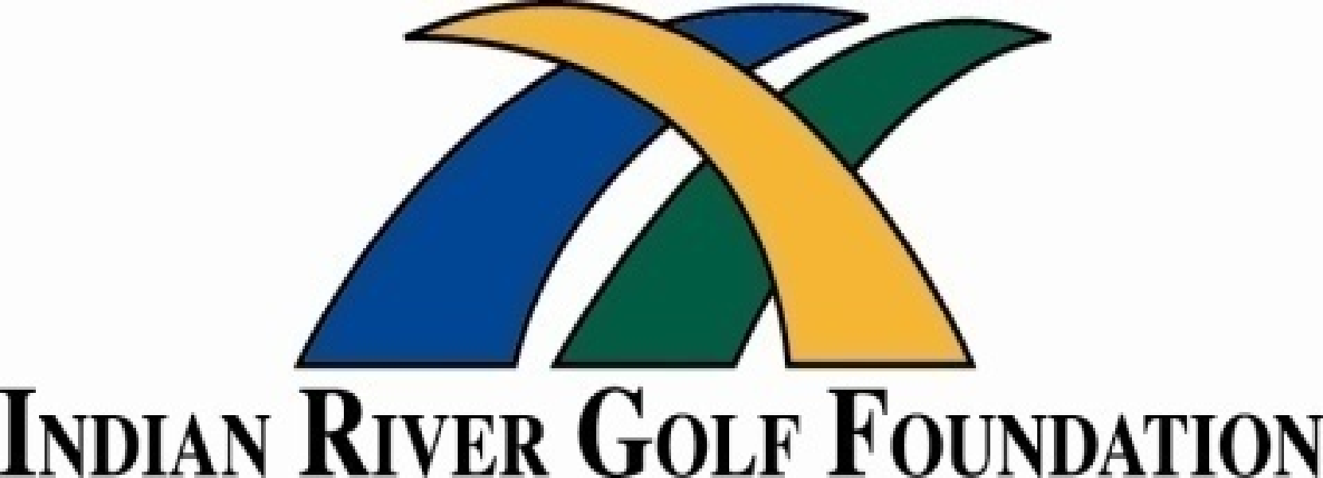

**Player's Club**

***8th Annual Player’s Advantage Golf Skills Qualifying & Championship***

***August - 2021***

The IRGF is pleased to announce **John’s Island Club** as the official host of the **8th Annual** **Player’s Advantage Golf Skills Championship**, which focuses primarily on Short Game Skills & Full-Swing Skills, to take place on the Short Game practice area and Driving Range at the John’s Island Club. The championship will take place on the West Course at John’s Island Club. The IRGF Player's Club continues to provide Training, Practices and Qualifying Sessions throughout the year in our premiere After School Golf Programs. We also offer Player’s Advantage Skills Programs on Saturdays during our regular TEAM Scramble Series. For more information on the IRGF Player's Club schedule, please visit the IRGF web site at **www.irgf.org**

***Awards and Prizes***

Winners of the Boys Divisions (3 age groups) will each receive the **Sal Spallone Golf Skills Award**. Winners of the Girls Divisions (3 age groups) will each receive the **Jackie Stoelting Golf Skills Award**. The names of the winning boy and girl for High School, Middle School and Elementary School players will be engraved on the plates of the traveling trophies, making for an incredible keepsake for years to come. All age groups will compete from the same skills stations to the same targets. Point totals will be converted into four categories of achievement. However, the ultimate prize is having fun and having a great day practicing your golfing skills at John’s Island Club, so we hope everyone considers themselves a winner.

***Skills Training Programs***

Are you interested in learning the skills displayed in our Player’s Advantage Golf Skills Championship, but have no golf experience? Fear not! Our Skills Qualifying training occurs weekly throughout the year to help you prepare for the Championship throughout the year. The following programs are offered as part of other junior golf programs:

* *After School Golf Training*
* *Treasure Coast Junior Tour TEAM SCRAMBLE Series*
* *TCJGT INDIVIDUAL Stroke Play Series*
* *PGA Junior League Golf*

This is a great opportunity for each player to assess their skills in the various aspects of their game. Not only that, but it is the perfect social distancing hobby! If you want to take up a new sport without worries of physical contact, give our golf training here at Indian River Golf Foundation a try!

***Player’s Advantage Golf Skills Schedule***

When you are a part of the Championship, you are putting your learning to the test. However, that does not mean that you will not be learning along the way! Instruction and golf tips are part of the experience.

Here at IRGF’s Player’s Advantage Golf Skills Championship, we encourage all participants to play as best as they can. That is why we encourage players to improve their score as many times as they desire. If the player decides to replay a round in order to get their best scores, each player is required to notify officials of their intentions to participate in an evaluation session, acquire a qualifying scorecard and begin the session at 7 Short Game Skills stations and 4 Full-Swing Skills stations. Take a look at our Golf Skills schedule and requirements below to start practicing today:

**Basic Short Game (Green Zone) Specialty Short Game (Green) Full-Swing Skills (Red Zone)**

**(4) Stations (3) Stations (4) Stations**

String Putting Pitch Shots PW or 9 Iron

Curve Putting Lob Shots 7 Iron

Distance Control Putting Bunker Shots 5 Iron or Hybrid

Chip Shots Driver

*** All scorecards MUST be signed and attested by a fellow competitor or Official Scorer.

*A* ***$15*** *fee will be charged for the Championship.*

**(if you are unable to pay directly, you may qualify for one of the many scholarships available)**

**8th Annual Player's Advantage Golf Skills Championship (all players eligible):**

**August - 2021**  **John's Island Club (West Course)**

*Parent Coaches & IRGF Staff will be available to assist at each golf skills station.*

***Register: roger.vandyke@comcast.net*** *Check for $15 payable to* ***IRGF at Logo Tent.***

***Ask for an advanced copy of Golf Skills Stations for practice purposes***

*Age Groups: High School - Middle School - Upper Elementary - Lower Elementary School Divisions*

To register for the **Player's Advantage Golf Skills Championship**, please contact:



**Roger Van Dyke, President**

                 Indian River Golf Foundation

PGA Life Master Professional

            rogervandykeirgf@gmail.com

                             (772) 713-9593

We look forward to seeing you at John’s Island Club next year!

[**www.irgf.org**](http://www.irgf.org)

  *Sal Spallone Golf Skills Award* *Jackie Stoelting Golf Skills Award*

***Sal Spallone*** is a graduate of St. Edwards School winning the FHSAA State Golf Championships……..Texas Christian University (All American)……and reached the level of Nationwide Tour (now Web.Com Tour) and PGA Tour experience.  He now resides in Vero Beach and serves as Director of Instruction at Bent Pine Golf Club. He is a Player Development Consultant for the IRGF a major contributor of his time and talents in youth golf.

***Jackie Stoelting*** is a graduate of Vero Beach High School competing in FHSAA State Golf Championships…...Florida Southern College - Lakeland, FL (2nd Team All American)……and after three years on the Symetra Tour achieved Full Status on the LPGA Tour.  Jackie is the 2014 winner of Big Break - Florida....a two-time winner on the Symetra Tour in 2015 and two-time winner in 2016. She is a current member of the LPGA Tour. She is a contributor of her time and talents for the IRGF demonstrating support of Player Development